**EXPERIMENT-3**

**NAME:** SHAIKH MUBASHIRA TUFEL AHMED

**ROLL NO:** 612055 **COURSE:** ADVANCE DEVOPS(ITL504)

**BRANCH:** T.E. INFORMATION TECHNOLOGY (SEM 5)

1. **What is AWS Cloud9 ? Features of AWS Cloud9.**

🡺AWS Cloud9 is an integrated development environment, or IDE.

The AWS Cloud9 IDE offers a rich code-editing experience with support for several programming languages and runtime debuggers, and a built-in terminal. It contains a collection of tools that you use to code, build, run, test, and debug software, and helps you release software to the cloud.

You access the AWS Cloud9 IDE through a web browser. You can configure the IDE to your preferences. You can switch color themes, bind shortcut keys, enable programming language-specific syntax coloring and code formatting, and more.

🡺**Features of AWS Cloud9:**

* Fully-featured Editor
* Broad Selection of Run Configurations
* Integrated Debugger
* Integrated Tools for Serverless Development
* Connectivity to Any Linux Server Platform
* Built-in Terminal
* Collaborative Editing and Chat
* Continuous Delivery Toolchain
* File Revision History
* Themes
* Keyboard Shortcuts
* Built-in Image Editor

**Step 1: AWS Management Console Dashboard.**

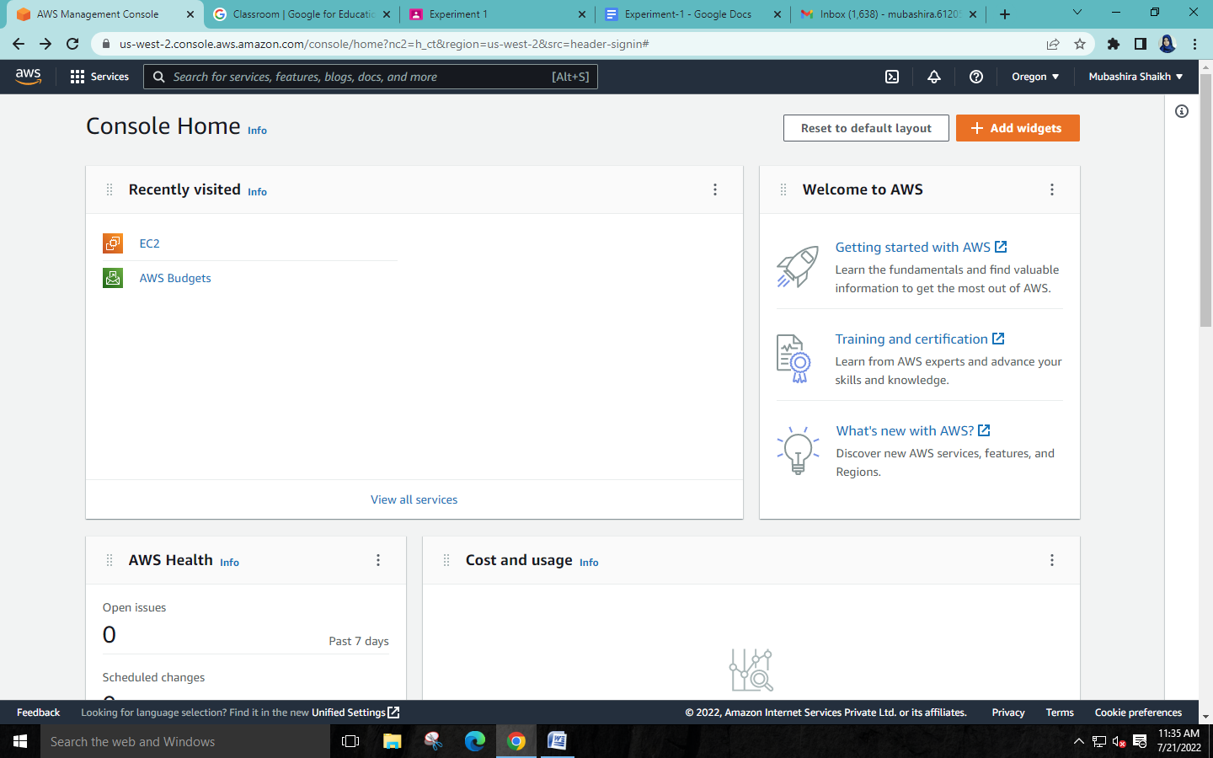

**Step 2: Search for Cloud9 and select it.**

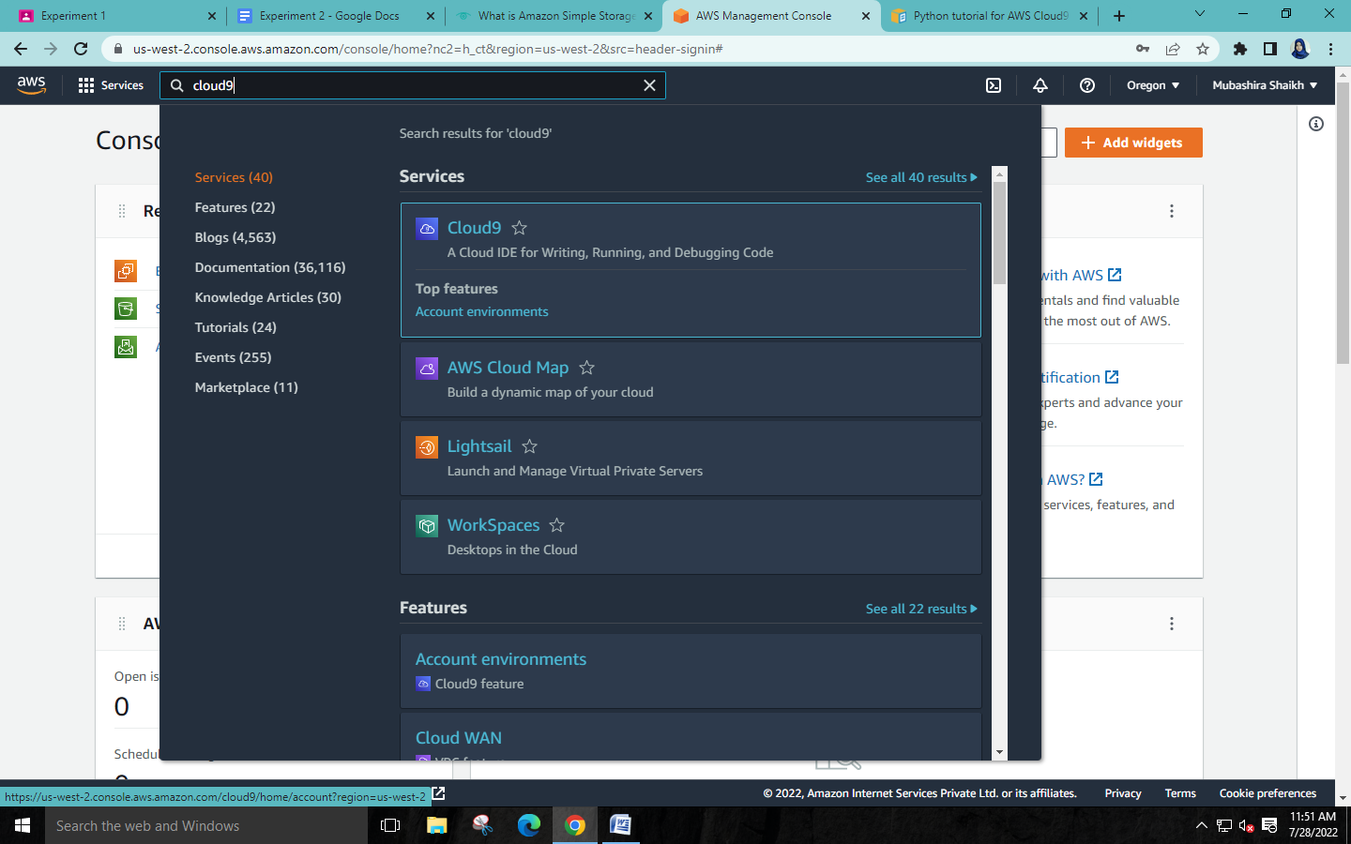

**Step 3: Click on ‘Create environment’.**

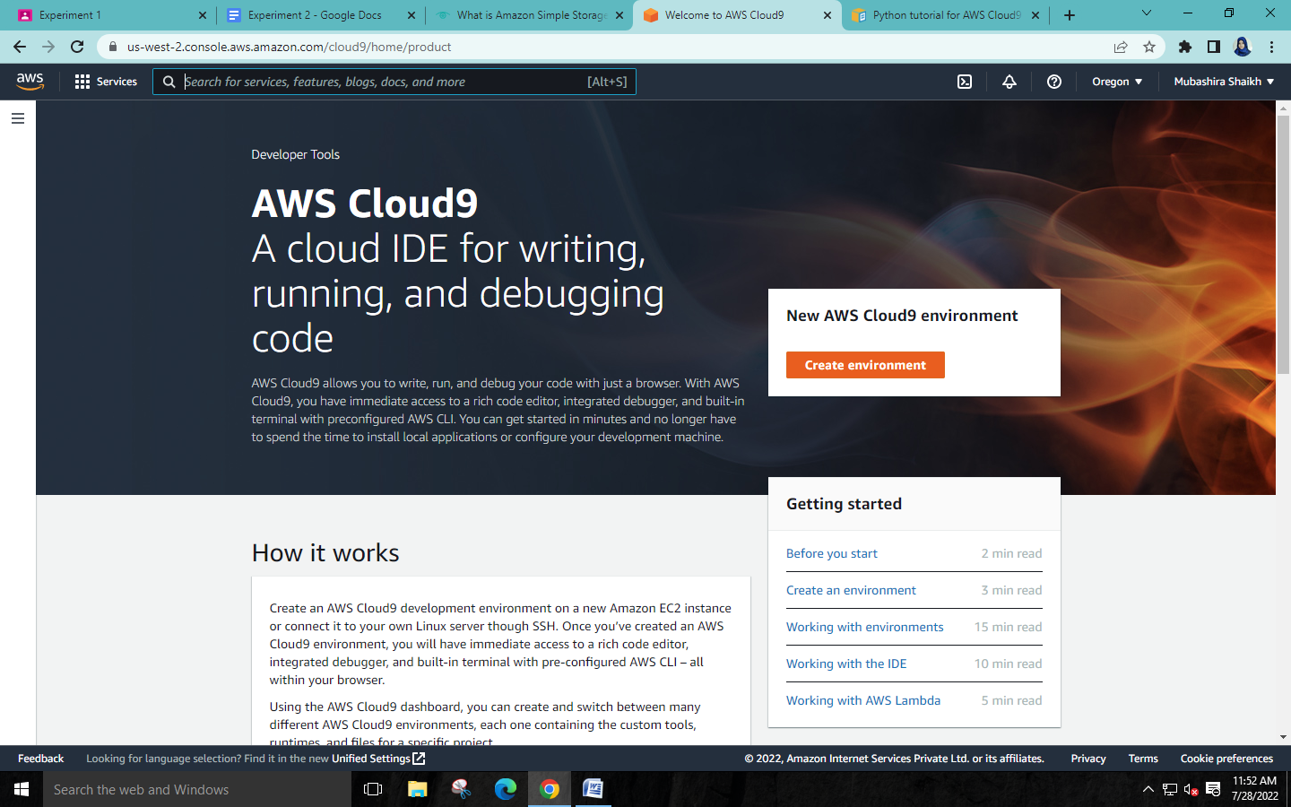

**Step 4: Name your environment and configure the settings.**

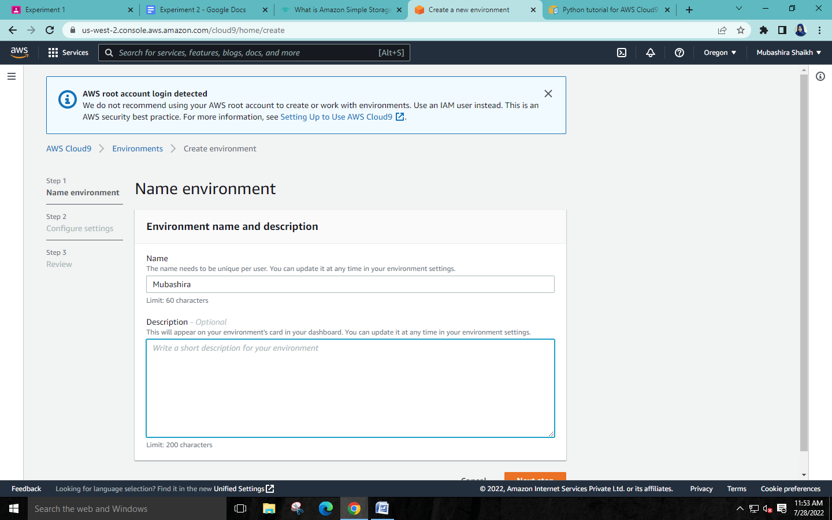

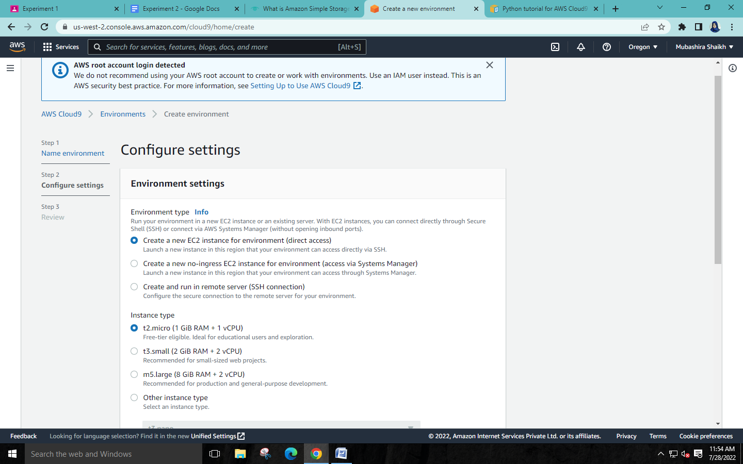

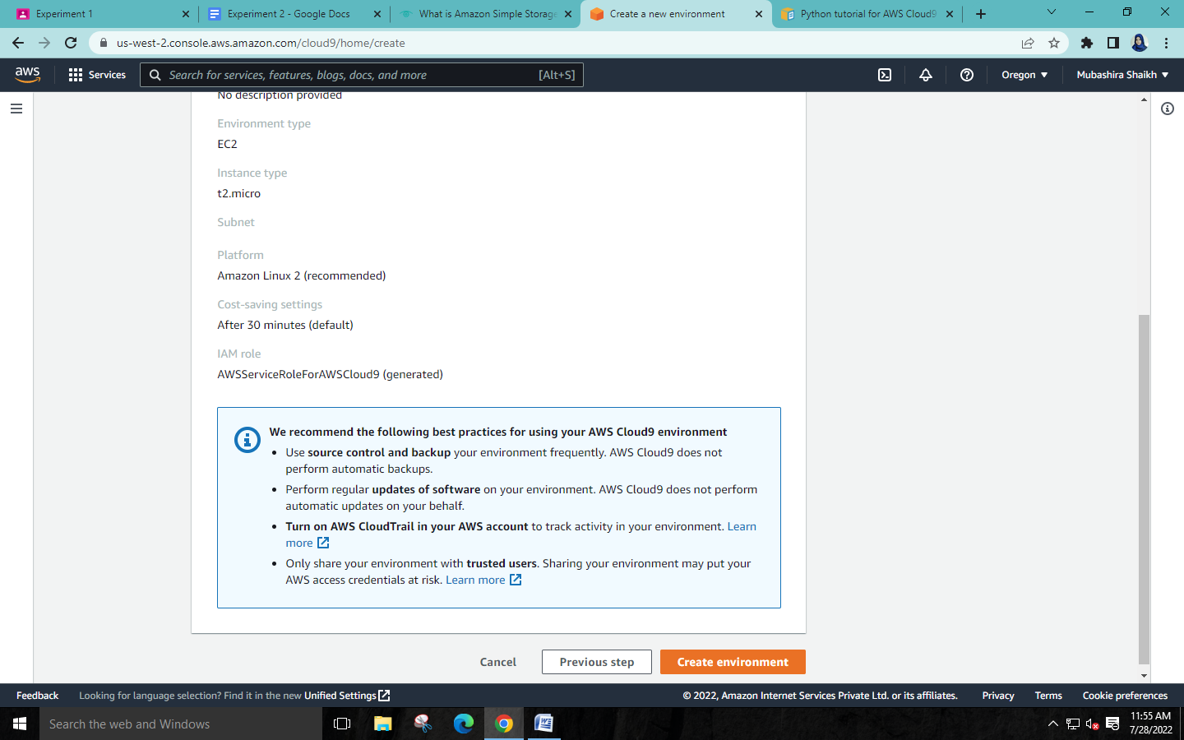

**FOR PYTHON:**

**Step 1: Install Python.**

Run the **yum update** for Amazon Linux to help ensure the latest security updates and bug fixes are installed: *sudo yum -y update.* Install Python by running the installcommand. For Amazon Linux: *sudo yum -y install python3*

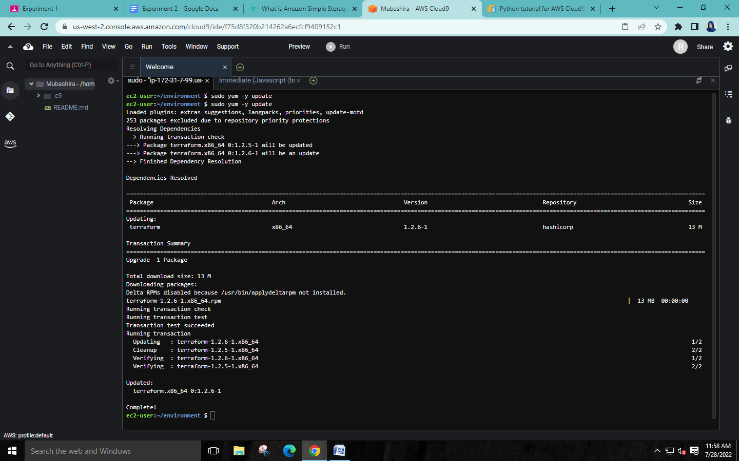

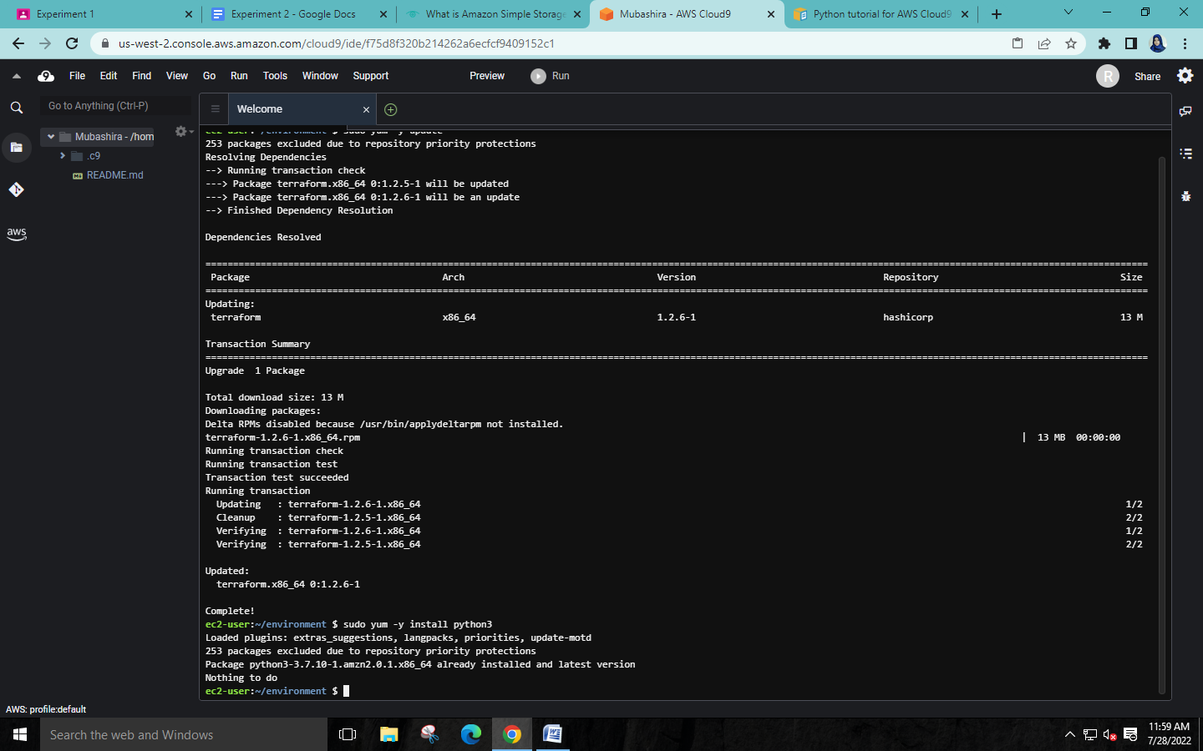**Step 2: Add code**

In the AWS Cloud9 IDE, create a file with the python code and save the file with some name.

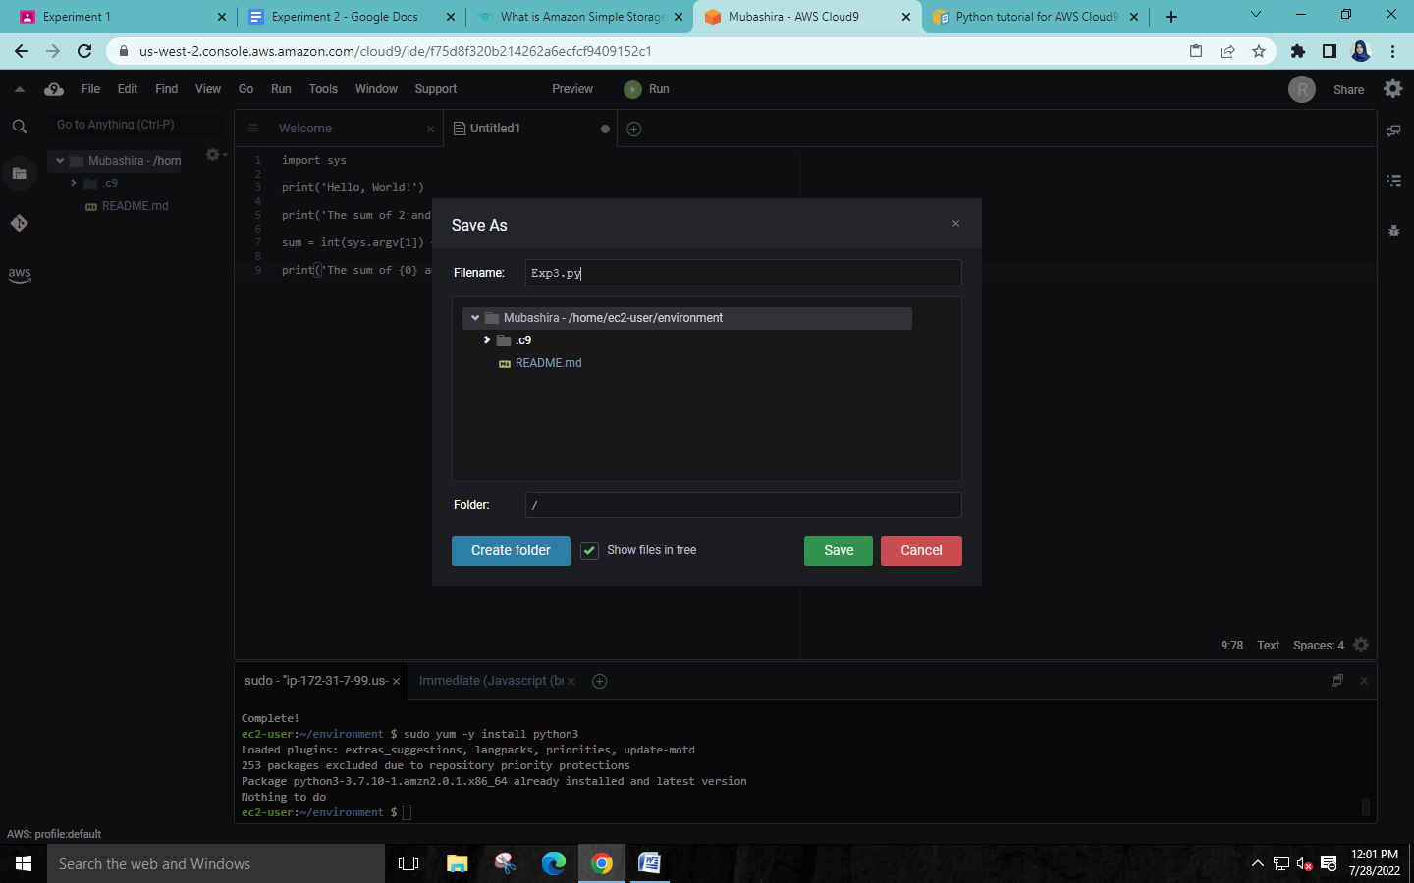

**Step 3: Run the code.**

1. In AWS Cloud9 IDE, on the menu bar choose Run -> Run Configurations -> New Run Configuration.
2. On the [New] - Stopped tab, enter filename.py 3 5 for Command.
3. Choose Run.

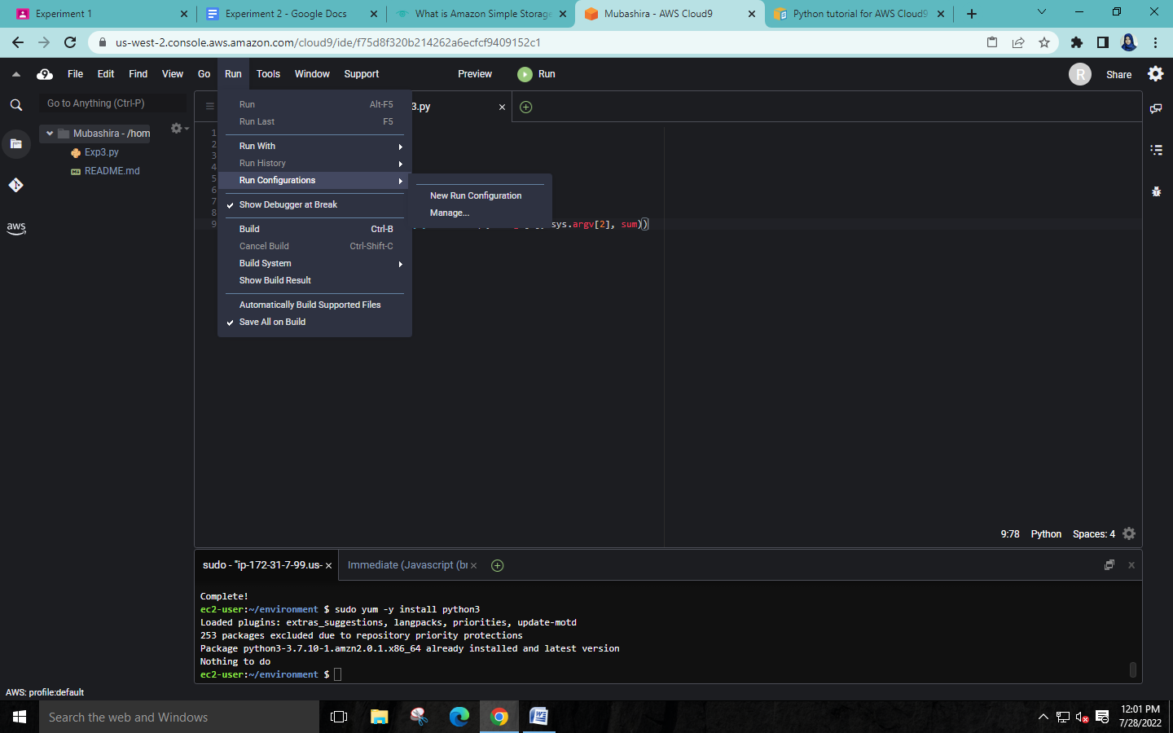

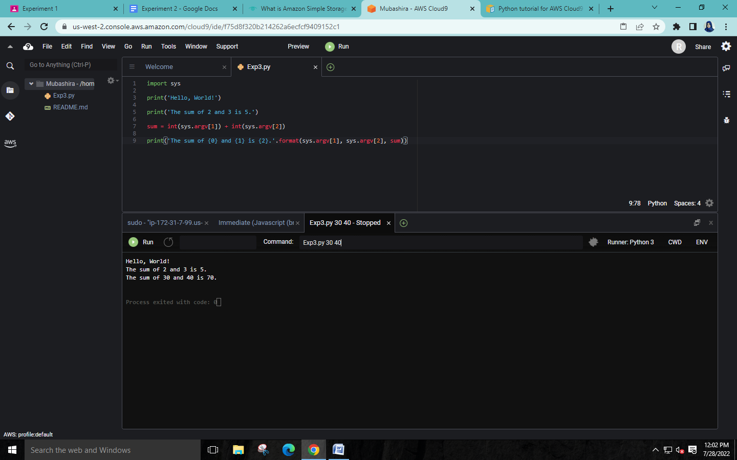

**Step 4: Install and configure the AWS SDK for Python(Boto3).**

1. Install pip: sudo python3.7 get-pip.py
2. Install the AWS SDK for Python (Boto3) - After you install pip, install the AWS SDK for Python

3. (Boto3) by running the pip install command.

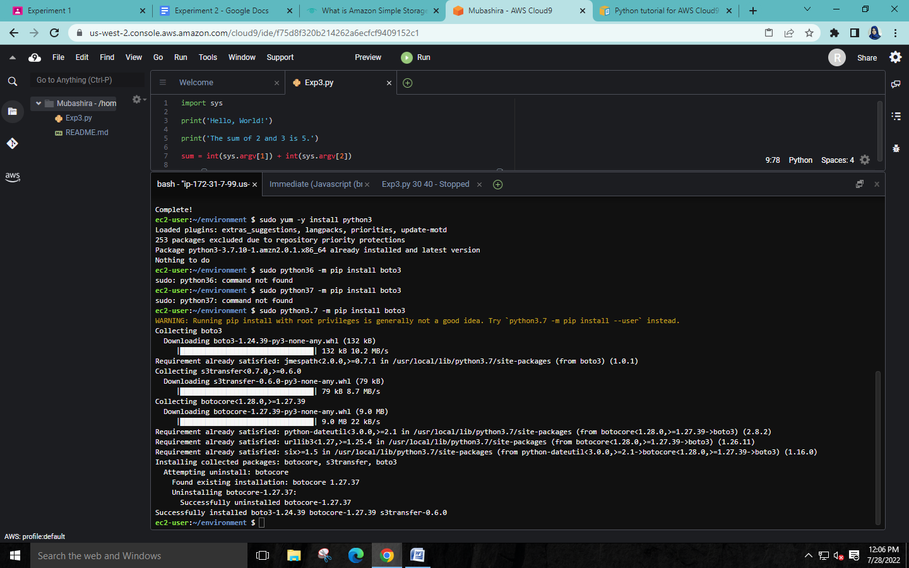**Step 5: Add AWS SDK code.**

Add code that uses Amazon S3 to create a bucket, list your available buckets, and optionally delete the bucket you just created.

In the AWS Cloud9 IDE, create a file with the code content and save the file with some name.

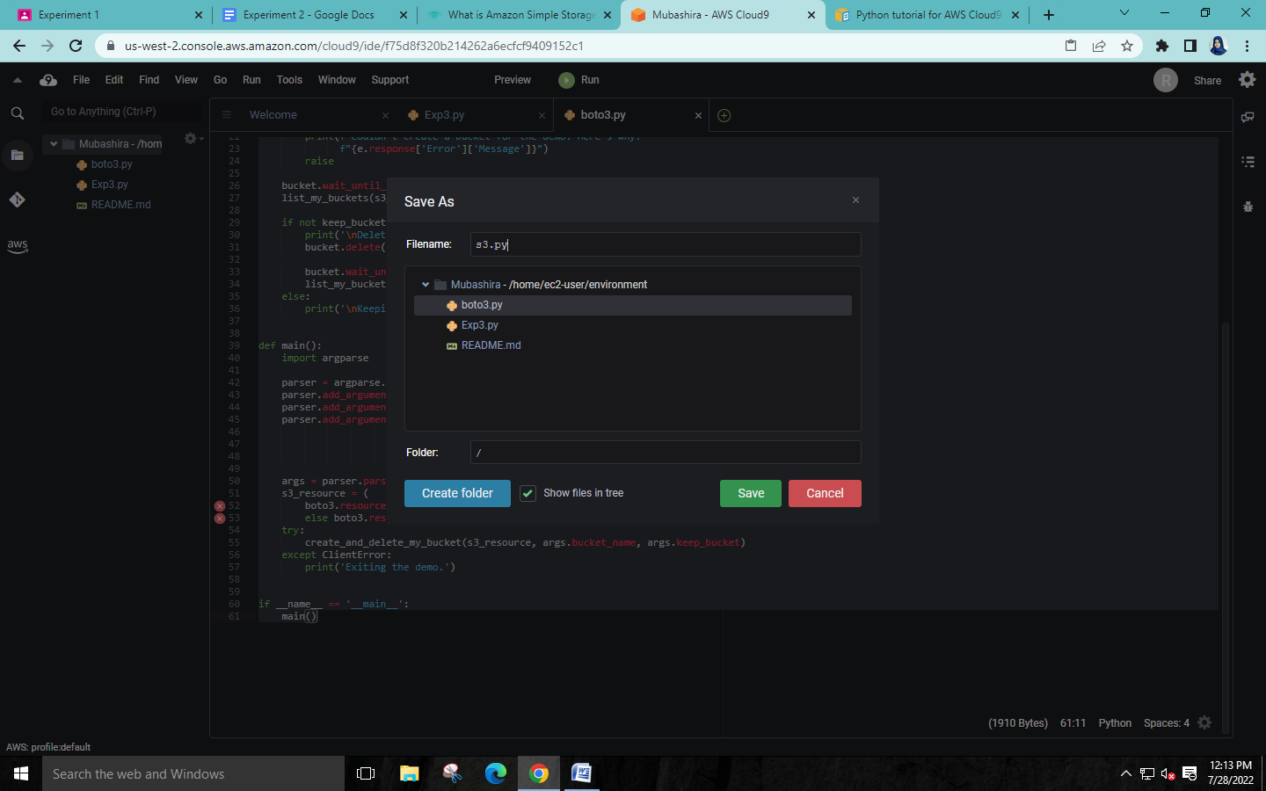

**Step 6: Run the AWS SDK code.**

1. On the menu bar choose Run -> Run Configurations -> New Run Configuration.
2. For Command, enter filename.py ‘name of bucket’ us-west-2, where us-west-2 is the ID of the AWS

Region where your bucket is created. By default, your bucket is deleted before the script exits.

1. Choose Run.

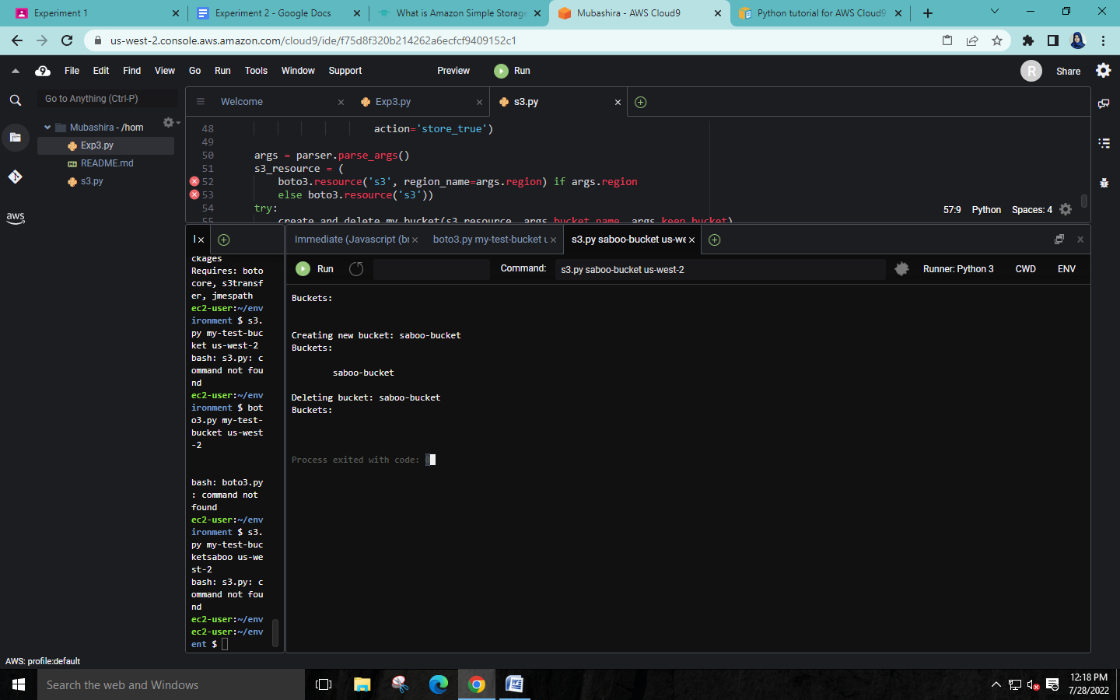

Either delete the current Cloud9 environment and create a new one to run the Node.js scripts or close all the python files and continue in the same environment.

**FOR NODE.JS:**

**Step 1: Install required tools.**

Run the **yum update** for Amazon Linux to help ensure the latest security updates and bug fixes are installed: *sudo yum -y update*

Run this command to install Node.js – nvm install v16.0.0

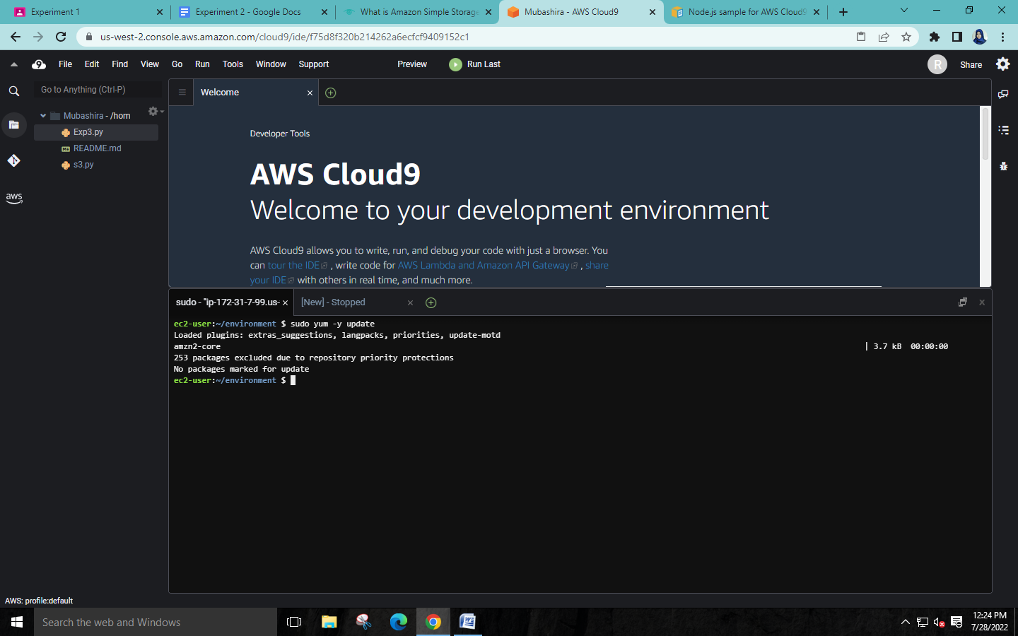



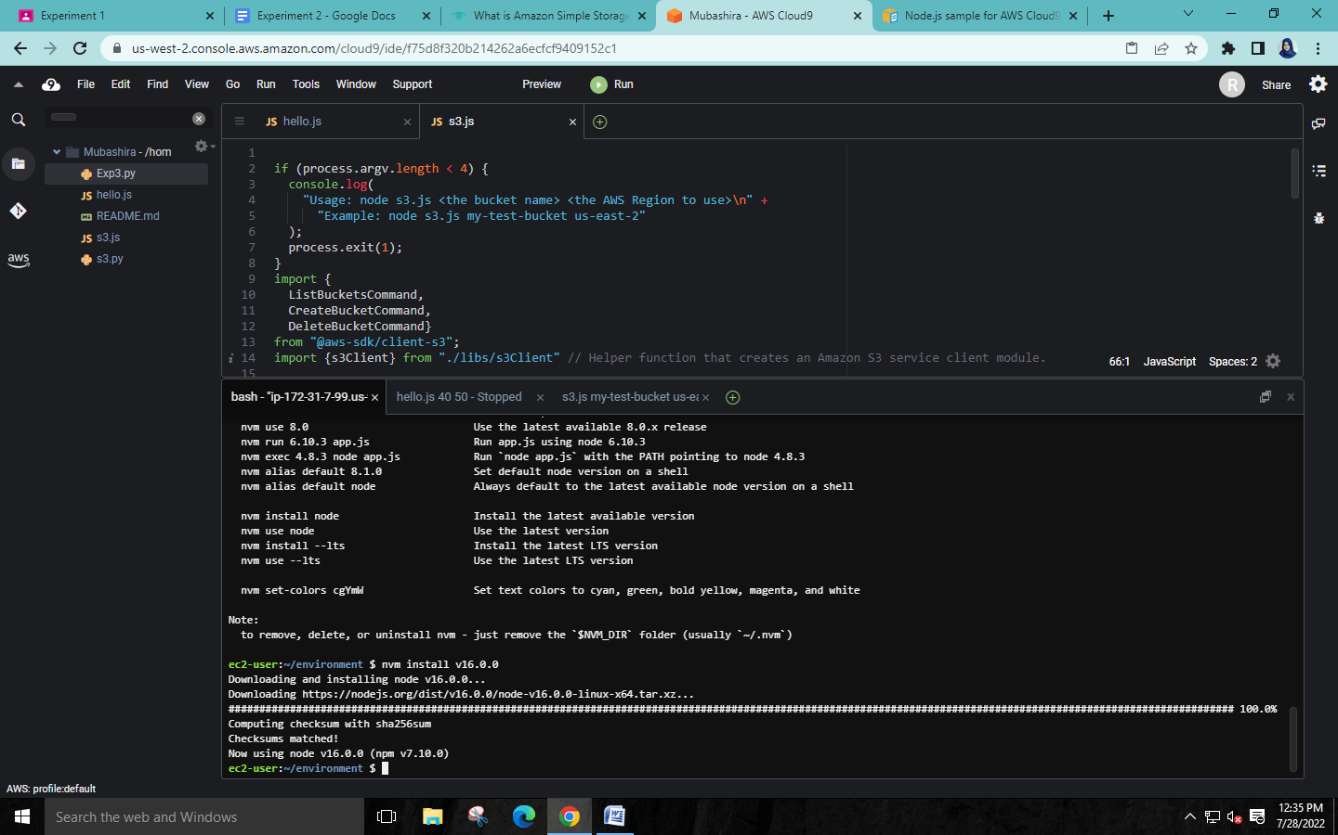**Step 2: Add code**

In the AWS Cloud9 IDE, create a file with the *node.js* code and save the file with some name.

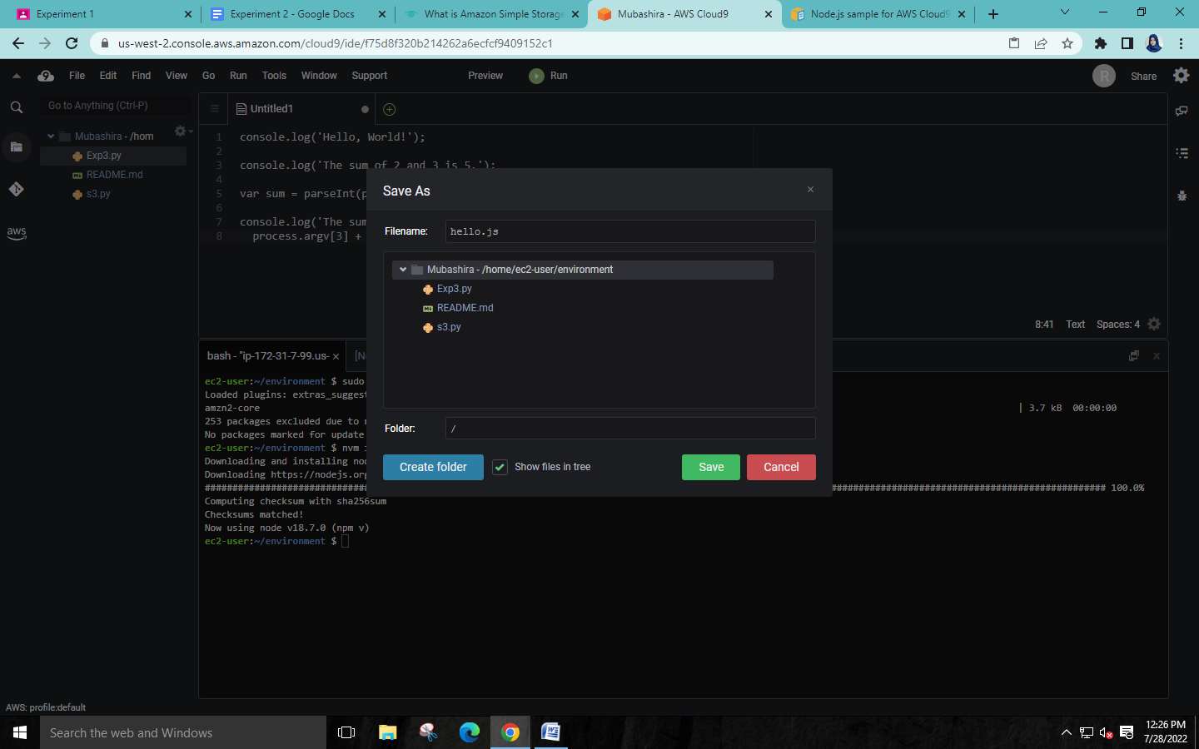

**Step 3: Run the code.**

1. In AWS Cloud9 IDE, on the menu bar choose Run -> Run Configurations -> New

Run Configuration.

1. On the [New] - Idle tab, enter filename.js 3 5 for Command.
2. Choose Run.

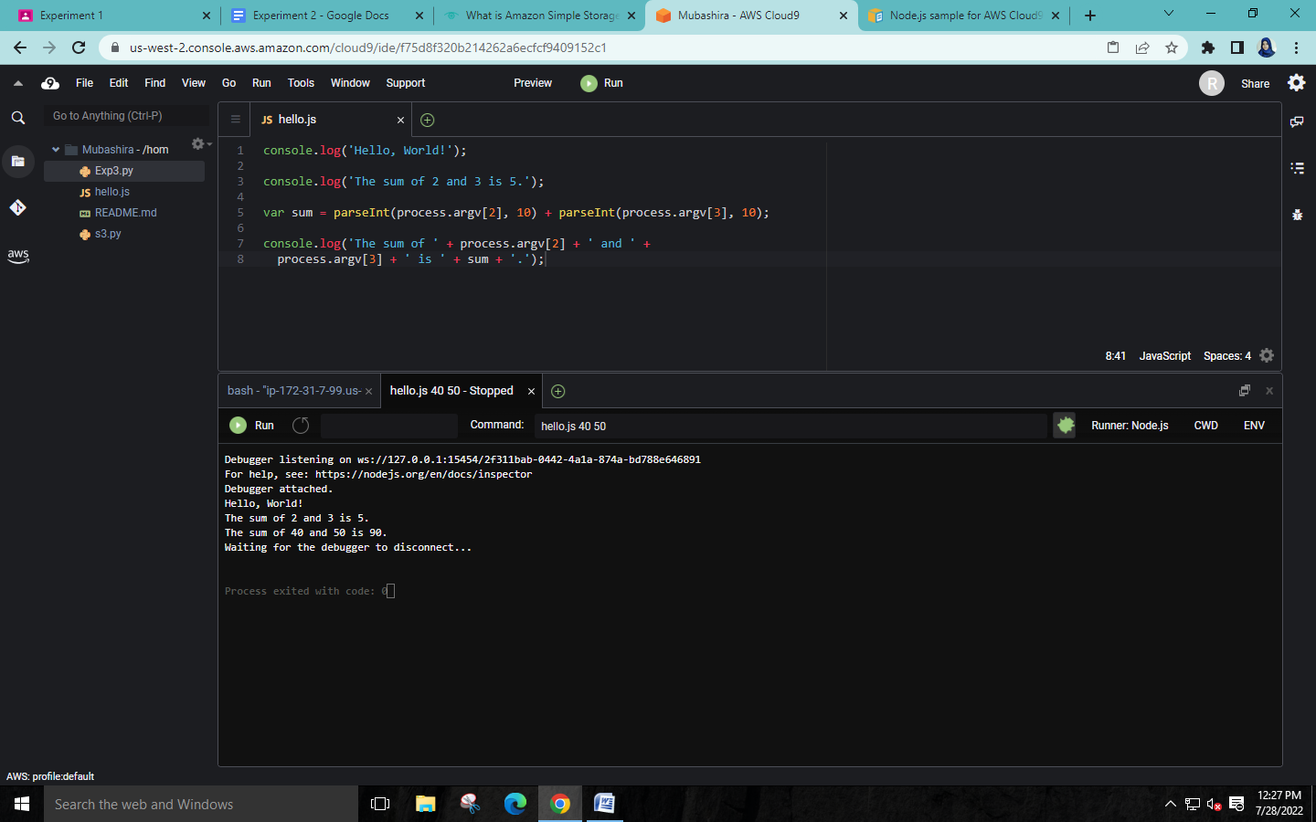

**Step 4: Install and configure the AWS SDK for JavaScript in Node.js.**

To install the AWS SDK for JavaScript(V2) in Node.js Use npm to run the install command.

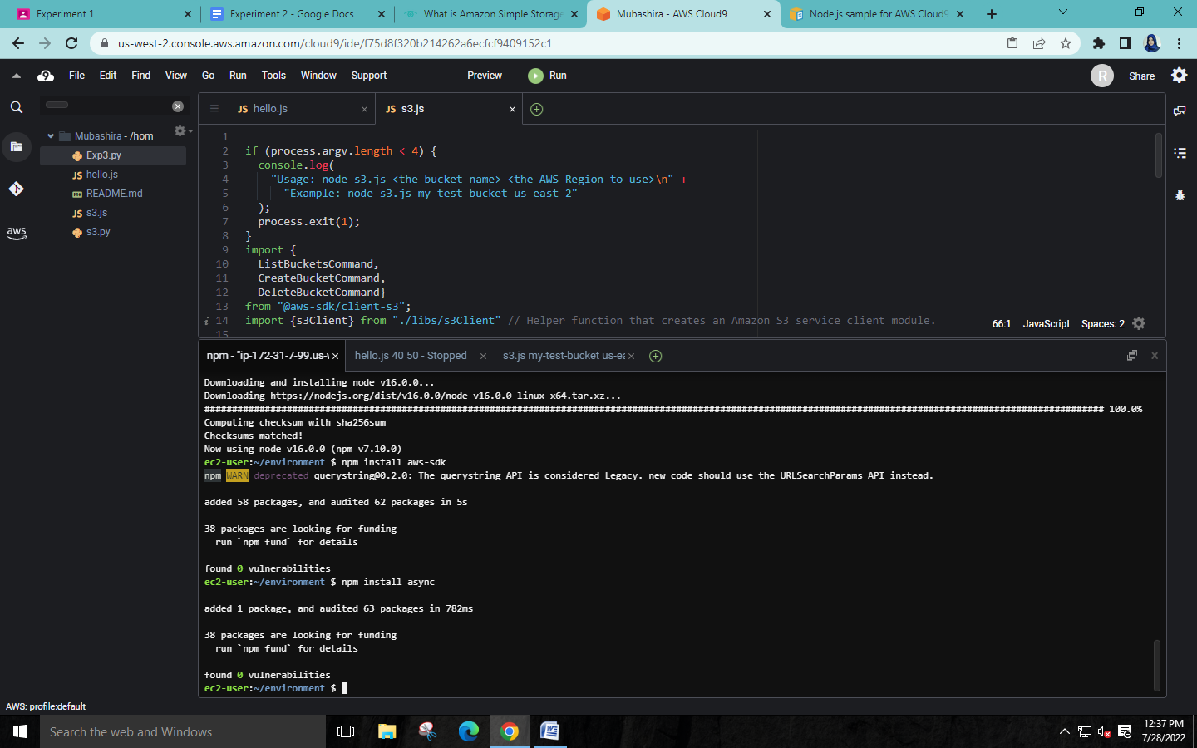

**Step 5: Add AWS SDK code.**

In this step, you add some more code, this time to interact with Amazon S3 to create a bucket, list your available buckets, and then delete the bucket you just created.

In the AWS Cloud9 IDE, create a file with the code content, and save the file with some name s3.js.

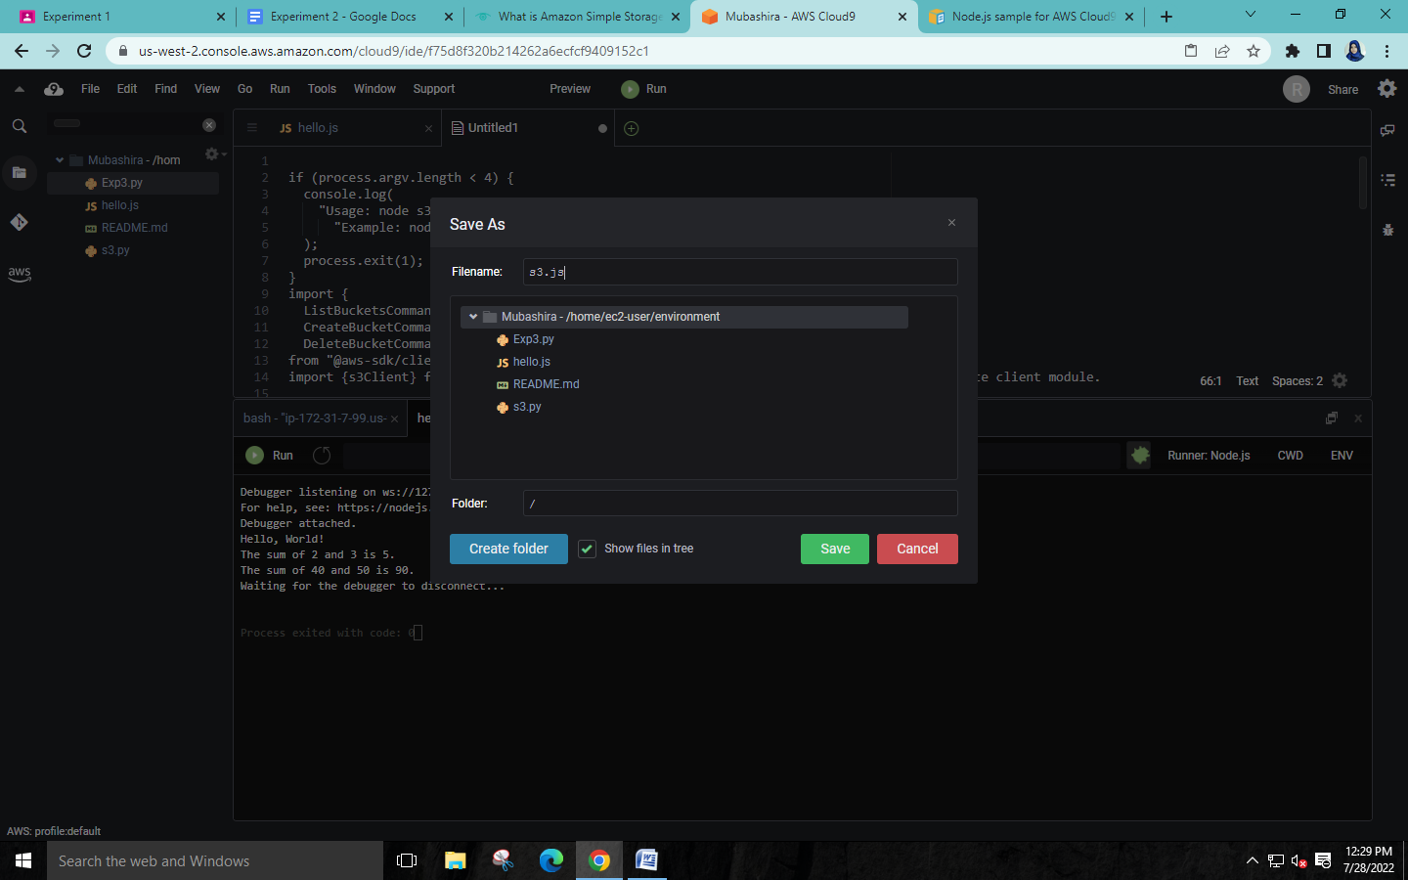

**Step 6: Run the AWS SDK code.**

1. Enable the code to call Amazon S3 operations asynchronously by using npm to run the install command → npm install async



1. On the menu bar choose Run -> Run Configurations -> New Run Configuration.
2. For Command, type filename.js ‘name of bucket’ us-east-2, where useast-2 is the ID of the AWS Region you want to create the bucket in.
3. Choose Run.

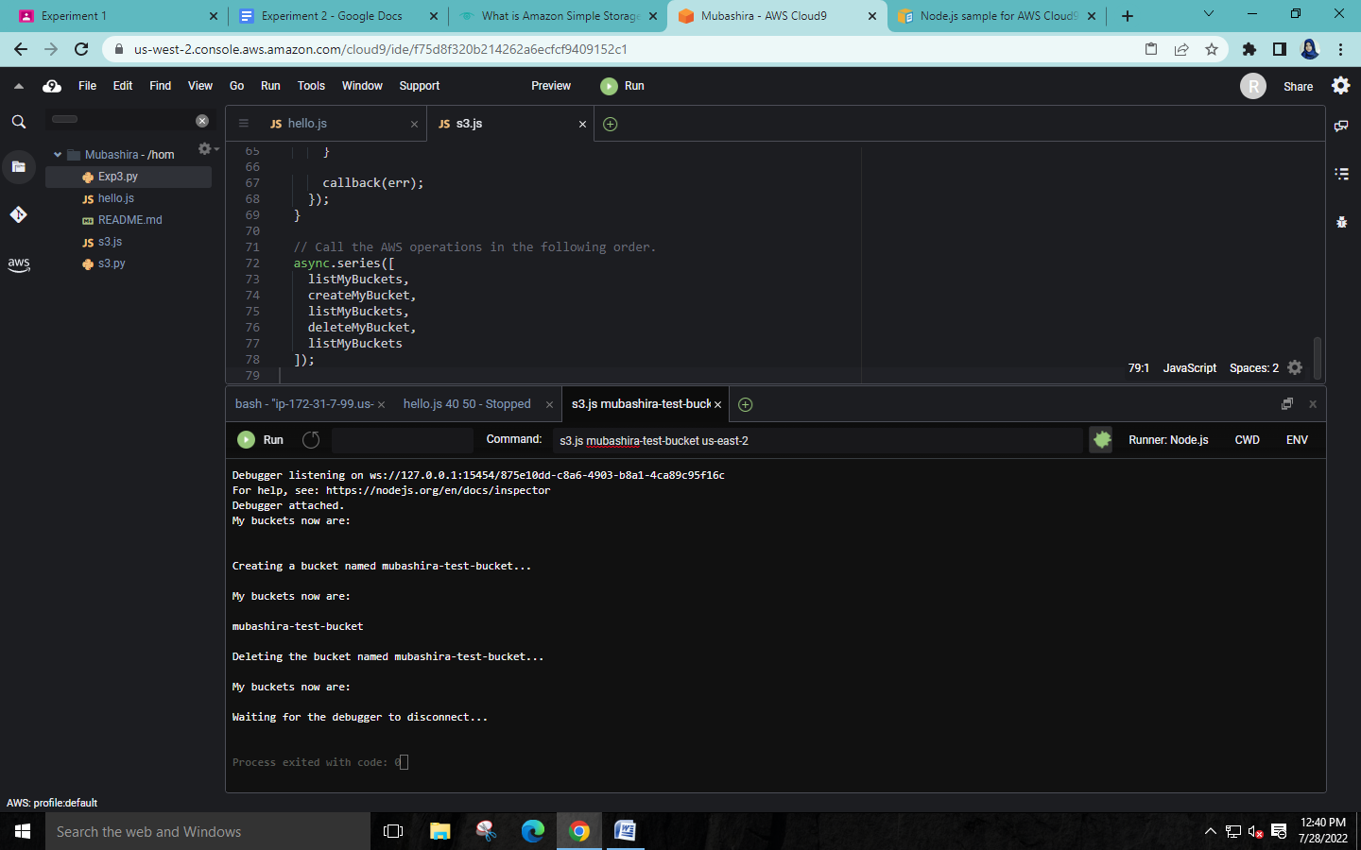

Finally, close all terminals and delete the Cloud9 environment.